Jeff Sherard
CSC160C11
6/8/2013 4:00 PM

Documentation for Ch02_Ex12 Program

Problem Analysis

Write a program that prompts the capacity, in gallons, of an automobile fuel tank and the miles per gallon the automobile can be driven. The program outputs the number of miles the automobile can be driven without refueling.

The program must output to the screen as follows:

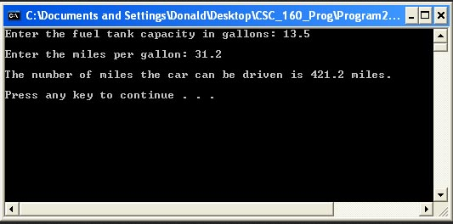

Algorithm

- Define variables:
  - fuel_tank_capacity
  - miles_per_gallon
  - miles_car_can_be_driven
- Get input:
  - fuel_tank_capacity = ??
  - miles_per_gallon = ??
- Calculate:
  - miles_car_can_be_driven = fuel_tank_capacity * miles_per_gallon
- Output:
  - miles_car_can_be_driven

User Documentation

To run the program the user will double click Ch3_Ex12.exe located on the C drive. After the program has loaded and the design is displayed, the user will be prompted to, “Press any key to continue…” which will terminate the program.

